Warehouse Management System

# Vision Statement:

An inventory management system has several critical components. At its core, inventory control works by tracking the two main functions of a warehouse: receiving (incoming) and shipping (outgoing). Other activities such as the movement or relocation of inventory also take place. Raw materials are decremented and finished goods are incremented.

# Objectives:

* To view all the available reports related to Customer.
* To view all the available reports related to Inventory.
* To view all the available reports related to Payment.
* To view all the available reports related to Receiving Stock.
* To view all the available reports related to Supplier.
* To view all the available reports related to Purchasing.

# User Stories:

Enabling all the details regarding below use cases:

* Incoming shipments
* Outgoing orders
* Inventory
* Suppliers
* Current Inventory
* Incoming Purchases
* Orders to Ship
* Reports

We are also trying to develop Barcode also for products and to use Barcode Scanner.

# UML:

* Use case
* Class
* Activity

# Use case Diagram:

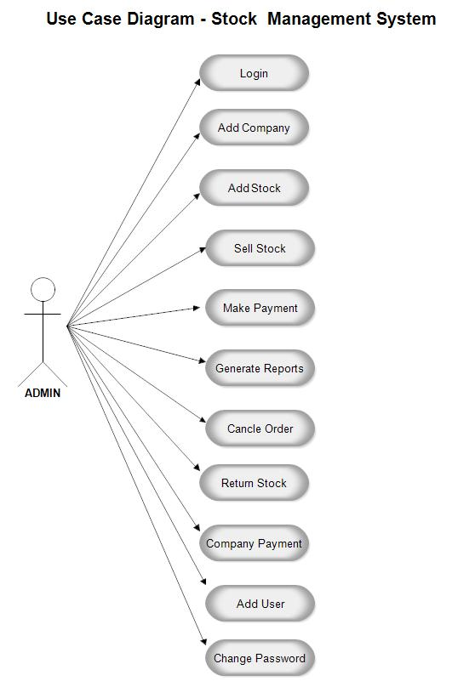

# Class Diagram:

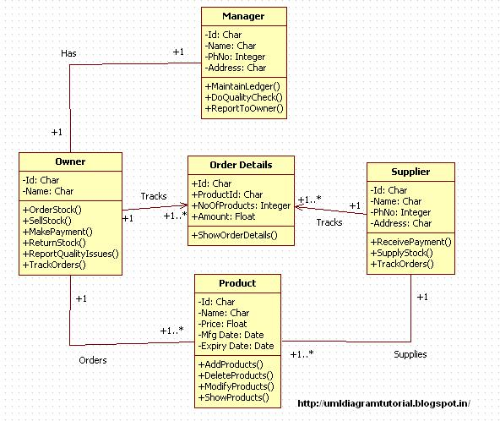

# Activity Diagram:

